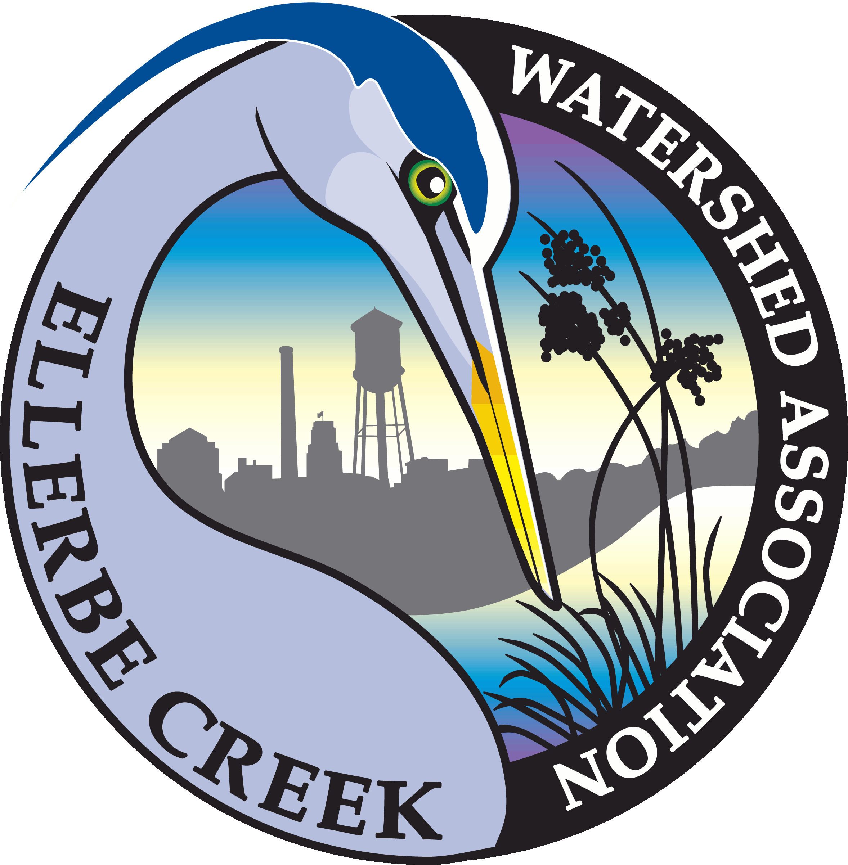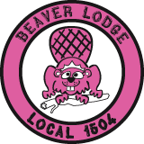**Ellerbe Creek Watershed Association**

**The 17th Annual Beaver Queen Pageant Is Underway!**

For Immediate Release

May 4, 2021

***Durham, NC*** – The 17th Annual Beaver Queen Pageant, World Wide Wood, is now on the interwebs at [www.beaverqueen.org](http://www.beaverqueen.org). The physical distancing required due to COVID-19 will prevent us from gathering in the Duke Park meadow, but it CANNOT and WILL NOT stop us from celebrating our inner beavers and our local wetlands!

The Beaver Queen Pageant is Durham’s own special mix of folly, pageantry, and humor. Contestants take on beaver personalities and introduce themselves in their wetlands ready wear, showcase their unique talent, and participate in an interview in their finest evening wear. This year’s pageant will have these same components, rolled out into three online episodes! There will be an introductory episode released on May 8th, a talent episode on June 5th, and a final CORONAtion episode on June 12th. All episodes will premiere at 6pm on the Beaver Queen Pageant website, [www.beaverqueen.org](http://www.beaverqueen.org), and will also be available on YouTube, Facebook, and Instagram I-TV so you can view as soon as they are posted or wait till you have time to view with your own beaver den.

The Beaver Queen Pageant is uniquely Durham: a mash-up of community, creativity, playfulness, and advocacy for a cause. The first event was held in April of 2005 in celebration of a successful community effort by residents of the Duke Park neighborhood to stop the NC Department of Transportation from eradicating a den of beavers that had taken up residence in wetlands north of Interstate 85. Beverly Woody was crowned the first Beaver Queen following an amazing clog dancing routine.

The event raises money for the Ellerbe Creek Watershed Association (ECWA). Past pageants have raised a combined $174,000 for Ellerbe Creek Watershed Association’s conservation activities in Durham. The lead business sponsors this year include Vaguely Reminiscent, Willow Oak Veterinary Hospital, Acme Plumbing, and Beer Study. G. Crabtree Spaces and Merge Records are sponsoring at the judge level. Members of the public are encouraged to check out the website for information on all our wonderful sponsors and for their favorite contestants at [www.beaverqueen.org](http://www.beaverqueen.org).

The mission of the Ellerbe Creek Watershed Association is to preserve, protect, and restore a healthy, living Ellerbe Creek watershed. Ellerbe Creek flows for more than 20 miles through Durham to Falls Lake, Raleigh’s water supply. Sadly, the creek is listed as one of North Carolina’s most polluted streams. The money raised through the Beaver Queen Pageant supports ECWA’s long-term goals for the watershed including creating an interconnected network of trails and nature preserves, restoring water quality and habitat in Ellerbe Creek, and creating green space for people in the community to enjoy. Since 1999, ECWA has protected over 450 acres of land along Ellerbe Creek and its tributary streams, restoring these forgotten and neglected areas into community assets as five public nature preserves.

For photos: <https://photos.app.goo.gl/u83nqtoJt4KFG2G28>

For more information: Rachel Cohn, 919-698-9729 or [rachel@ellerbecreek.org](mailto:rachel@ellerbecreek.org).

[www.ellerbecreek.org](http://www.ellerbecreek.org)

www.beaverqueen.org